Progressive Web Apps – HTML , css and JS is all you need

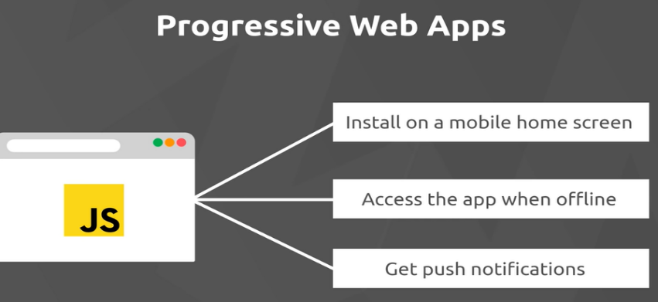

Native apps

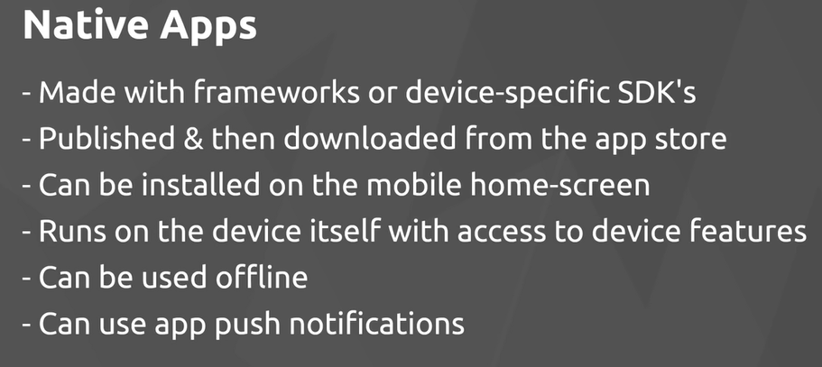

Service workers can be used to run off line

PWA’s are new and there are a lot of changes, not all browsers support

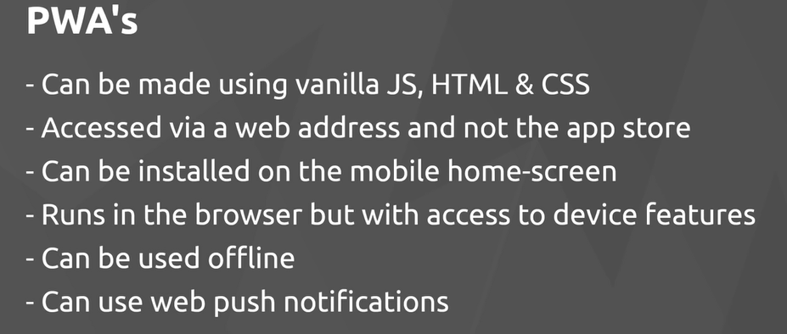

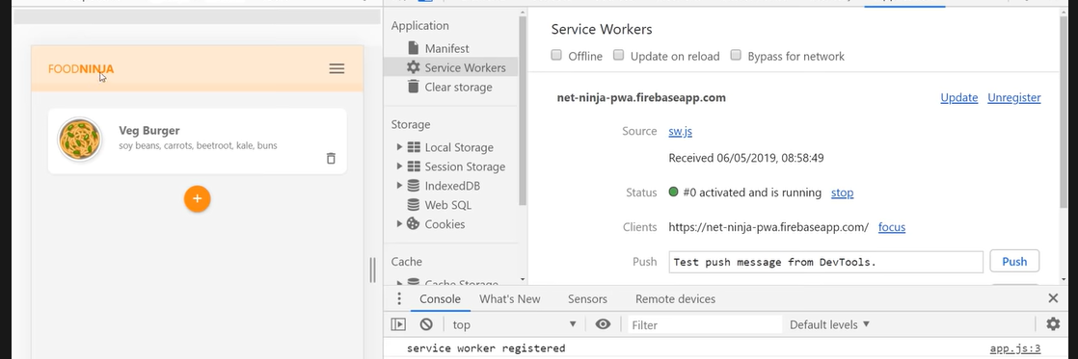

Video 2 <https://www.youtube.com/watch?v=JQaL5YiSuqE>

Using Materialize CSS for the app

Downloaded the min.css from materialize and min.js

Server page in HTML protocol – live server in VS code

Using Materialize to stye the page

#1- make it mobile device responsive

Video 3- The Web app Manifest file - info about how to display app – safari only partially supports

<https://www.youtube.com/watch?v=AlEdGOLhuM8>

Need to create a web app manifest file. A single JSON file which is going to supply info about app to the browser – name , home screen icon, color theme ect . So browser knows how to display the app on a mobile device.

<https://developer.mozilla.org/en-US/docs/Web/Manifest>

<https://web.dev/add-manifest/>

Must be called manifest.json and be in the root of the project –

Define the name that will be displayed on splash screen

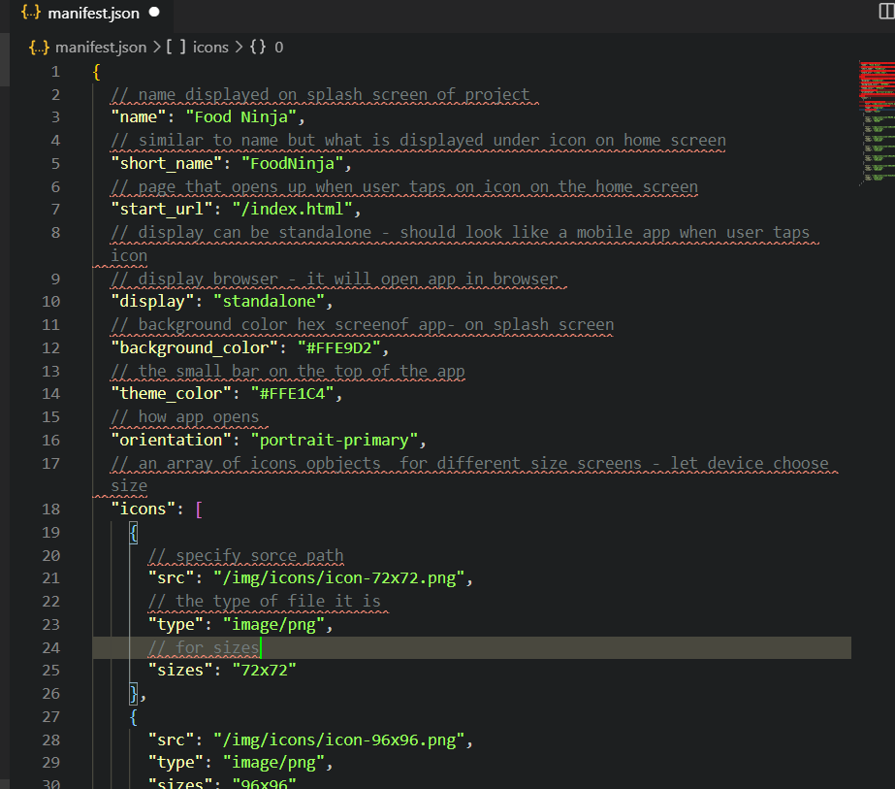

After creating the file create link to in in each HTML file.

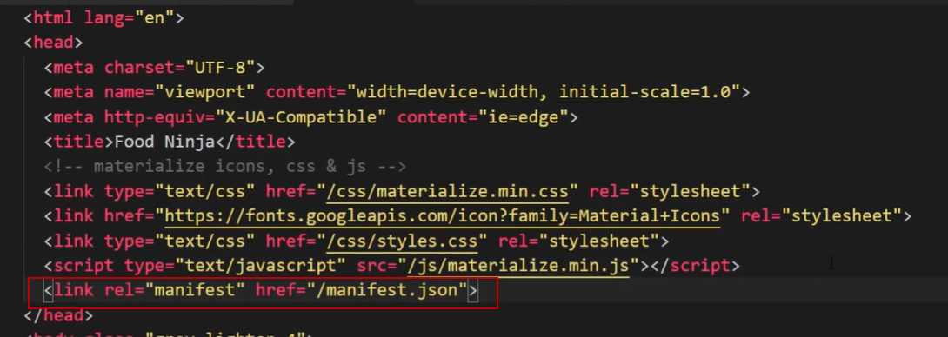

You can see this in dev tools under Application > Manifest

Video 4 – Android Emulator

<https://www.youtube.com/watch?v=1VVKhnHNBeQ>

iOS Support  Video 5

<https://www.youtube.com/watch?v=jy6hX48pRHw>

Some manifest stuff is not supported – Icons and Color of header bar

so need to

Add lint tag to HTML head – of each document

<link rel = “apple-touch-icon” href= “/icons/icon-96x96.png”

Could create additional for other sizes

Then add meta tag for color

<meta name=”apple-mobile-web-app-status-bar” content=”#aa7700”

Video 6 service workers –

<https://www.youtube.com/watch?v=jy6hX48pRHw>

The beating heart of progressive web apps

Load content off line

use backbround sync

use push notifications

PWA Tutorial 8 – register a service worker

<https://www.youtube.com/watch?v=6s697AJdlB8>

PWA video 9 Service worker install event

<https://www.youtube.com/watch?v=JnCEXQo_TiI>